KUMARAGURU COLLEGE OF TECHNOLOGY
DEPARTMENT OF ARTIFICIAL INTELLIGENCE AND DATA SCIENCE
24ADI006 – DEEP LEARNING
SELF-LEARNING ASSIGNMENT REPORT
EXPLORING WORD REPRESENTATIONS:
FROM TRADITIONAL WORD EMBEDDINGS TO TRANSFORMERS
Name: Mohamed Aashik S Roll Number: 24BAD072

1. Introduction
Natural language is made of words and sentences, while machine-learning algorithms operate on numerical inputs. Word representation techniques convert text into numerical features so that models can process language. Different techniques preserve different kinds of information: count-based methods record word occurrence, static embeddings learn a fixed vector for each word, and Transformer models produce representations influenced by surrounding context.
This assignment explores the progression from traditional representations to neural and contextual embeddings. The implementation notebook demonstrates One-Hot Encoding, Bag of Words (BoW), TF-IDF, N-grams, a word co-occurrence matrix, Latent Semantic Analysis (LSA), Word2Vec CBOW and Skip-gram, FastText, a TensorFlow/Keras Embedding layer, BERT contextual embeddings, cosine similarity and two-dimensional visualization.

2. Objectives
- Understand the strengths and limitations of traditional text vectorization.
- Train CBOW and Skip-gram Word2Vec models and retrieve semantically similar words.
- Test FastText’s ability to generate a vector for an unseen word.
- Train a Keras embedding model for topic classification and examine its evaluation result.
- Extract BERT token representations in two different contexts for the word “bank”.
- Visualize Word2Vec vectors using PCA and t-SNE and prepare files for TensorFlow Embedding Projector.
- Compare methods in terms of semantic representation, context awareness, OOV handling and computational cost.

3. Dataset Used
The uploaded notebook uses a built-in text dataset rather than downloading an external corpus. It contains 100 short documents grouped into 10 topics, with 10 documents per topic. Topics cover Artificial Intelligence, Machine Learning, Deep Learning, Natural Language Processing, Word Embeddings, Transformers and other Computer Science-related areas. The notebook reports 100 documents and 10 topics.
Text preprocessing converts text to lowercase and tokenizes it into words. The cleaned text is used for the traditional representations, predictive embeddings and classification model. Because the dataset is small and its documents are short and highly topic-focused, results are useful for demonstrating the methods but should not be treated as a benchmark for general language understanding.

4. Techniques Studied
Technique | Representation | Main idea | Main limitation
One-Hot Encoding | Sparse binary vector | One unique index is set to 1 for each word. | No similarity between different words; large vocabulary vectors.
Bag of Words | Sparse count vector | Counts words in a document without preserving word order. | Loses context and word order.
TF-IDF | Sparse weighted vector | Weights terms by document importance; common terms receive lower weight. | Does not directly model meaning or context.
N-grams | Sparse count vector | Adds adjacent word sequences such as bigrams. | Feature space grows quickly.
Co-occurrence + LSA | Matrix-based; reduced dense vectors | Counts nearby words and uses SVD to discover latent structure. | Requires matrix processing; still not context-specific.
Word2Vec CBOW | Dense static vector | Predicts a target word from surrounding context words. | One fixed vector per word; unseen words are not naturally represented.
Word2Vec Skip-gram | Dense static vector | Predicts surrounding words from a target word. | Can be slower; small data may produce noisy neighbours.
GloVe | Dense static vector | Learns vectors from global word co-occurrence statistics. | Requires pretrained vectors or a sufficiently large corpus.
FastText | Dense subword vector | Uses character n-grams to represent words. | Subword overlap does not guarantee correct interpretation.
Keras Embedding | Trainable dense vector | Learns an embedding table jointly with a downstream model. | Quality depends on data and task training.
BERT | Contextual token vector | Self-attention makes a token representation depend on its sentence. | More computationally expensive than count methods.
SBERT | Sentence vector | Produces sentence-level vectors for semantic comparison. | Pretrained inference costs more than simple sparse vectorization.

5. Implementation Configuration
Component | Notebook configuration / result
Corpus | 100 documents; 10 topics
Vocabulary after preprocessing | 367 unique words
BoW / TF-IDF | 100 × 366 feature matrices
Unigrams + bigrams | 100 × 985 matrix; 619 bigram features
Co-occurrence matrix | 367 × 367; context window size 2
LSA | 10 components; output 100 × 10; explained variance ratio 0.2127
Word2Vec CBOW and Skip-gram | 100-dimensional vectors; window 4; 100 epochs; vocabulary 367
FastText | 100-dimensional vectors; window 4; 100 epochs
Keras embedding layer | 64-dimensional learned word vectors
BERT | bert-base-uncased; 768-dimensional token representations

6. Experimental Results and Discussion

6.1 Traditional representations and LSA
The One-Hot demonstration produced a vocabulary of 367 words. Each word is represented by a vector with one active position. BoW and TF-IDF each produced a 100 × 366 matrix. TF-IDF ranks terms by their relative importance in a document and corpus, but its representation remains based on term statistics rather than contextual meaning.
The combined unigram and bigram representation produced 985 features, including 619 bigrams. This illustrates how adding short word sequences increases the feature space. The word co-occurrence matrix was 367 × 367 and used a context window of two words on each side. LSA reduced the TF-IDF representation to 10 components; its total explained variance ratio was 0.2127, meaning the retained components captured about 21.27% of the input variance.

6.2 Word2Vec semantic similarity
Both CBOW and Skip-gram were trained from the notebook’s tokenized sentences. Each model learned a 100-dimensional vector for every word in the 367-word vocabulary. The notebook’s top-five Skip-gram neighbours are listed below. Similarity values are cosine similarities from this small, repetitive training corpus.
Query word | Top five similar words (cosine similarity)
learning | performance (0.9809), deep (0.9762), improve (0.9693), machine (0.9659), tuning (0.9617)
data | labeled (0.9787), supervised (0.9756), computing (0.9739), available (0.9716), optimization (0.9714)
computer | interpret (0.9791), vision (0.9779), robotics (0.9731), videos (0.9726), healthcare (0.9721)
language | natural (0.9797), understanding (0.9783), transformer (0.9755), processing (0.9747), many (0.9733)
embedding | space (0.9735), compared (0.9724), vectors (0.9723), be (0.9678), often (0.9677)
Interpretation: the neighbours often share topic or phrase context, such as “language”, “natural”, “understanding” and “processing”. However, cosine values are unusually high for many pairs. Because the training corpus contains only 100 short documents and repeated topic vocabulary, these results should be interpreted as a demonstration of the method rather than proof of broad semantic quality.

6.3 FastText and out-of-vocabulary handling
The notebook trained FastText with 100-dimensional vectors and a 4-word context window. “computer” was present in the vocabulary, while “computerization” was not. Despite being absent from the vocabulary list, FastText generated a vector for “computerization” from learned character subword n-grams. This is the main advantage over ordinary Word2Vec, which normally cannot return a trained vector for a word absent from its vocabulary.

6.4 TensorFlow/Keras Embedding Layer
The notebook converts each cleaned document into a fixed-length integer sequence using TensorFlow’s TextVectorization layer. A neural classifier is built with a 64-dimensional Embedding layer, GlobalAveragePooling1D, a 64-unit ReLU Dense layer and a softmax output layer for the 10 topics. The model is trained for 30 epochs with the Adam optimizer and sparse categorical cross-entropy loss.
Recorded test loss: 2.0536. Recorded test accuracy: 0.2500 (25%). This is weak performance for a 10-class task. A random baseline with balanced classes would be approximately 10%, so 25% indicates some learning, but the model does not generalize reliably. The small dataset, short examples and limited training data are likely constraints. The result should be reported honestly rather than described as high accuracy.

6.5 BERT contextual embedding experiment
The notebook loads the pretrained bert-base-uncased model and extracts the hidden-state vector corresponding to the target word “bank” in two sentences: (1) “I deposited money in the bank.” and (2) “We sat beside the bank of the river.” The target token is “bank” in both sentences. BERT produces 768-dimensional contextual token representations.
The notebook reports cosine similarity of 0.5121 between the two contextual representations. The moderate similarity indicates that the token vectors are not identical when the surrounding meaning changes. Unlike Word2Vec, which stores one static vector for “bank”, BERT uses sentence context to form the token representation. The vectors from Word2Vec and BERT should not be compared directly because they belong to different embedding spaces and have different dimensions.

7. Embedding Visualizations
The notebook selects 26 representative words related to machine learning, language, data, embeddings and computer science. It projects their 100-dimensional Skip-gram vectors into two dimensions. The following figures were regenerated using the visualization code and selected words in the uploaded notebook; the report text, tables and discussion are independently written.
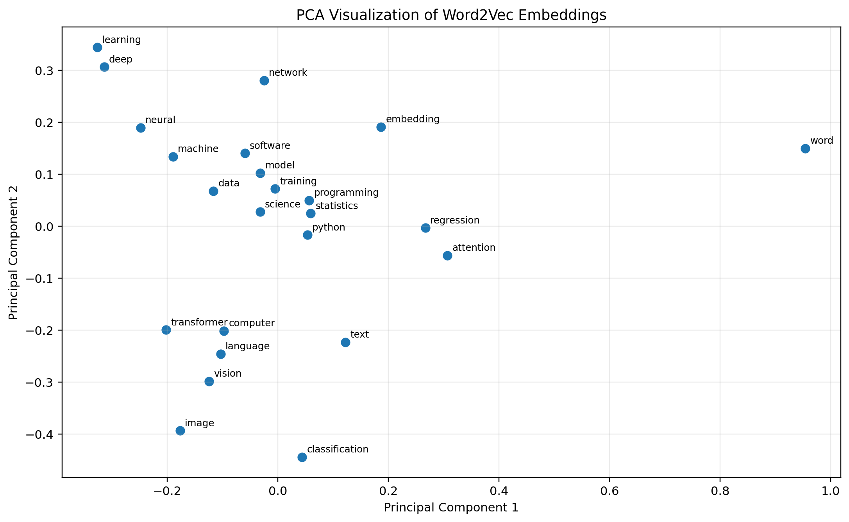
Figure 1. PCA projection of selected Word2Vec vectors. The first two components explain 46.50% of variance in the regenerated embedding run (the original notebook output reports 27.49% and 19.01%).

7. Embedding Visualizations (continued)
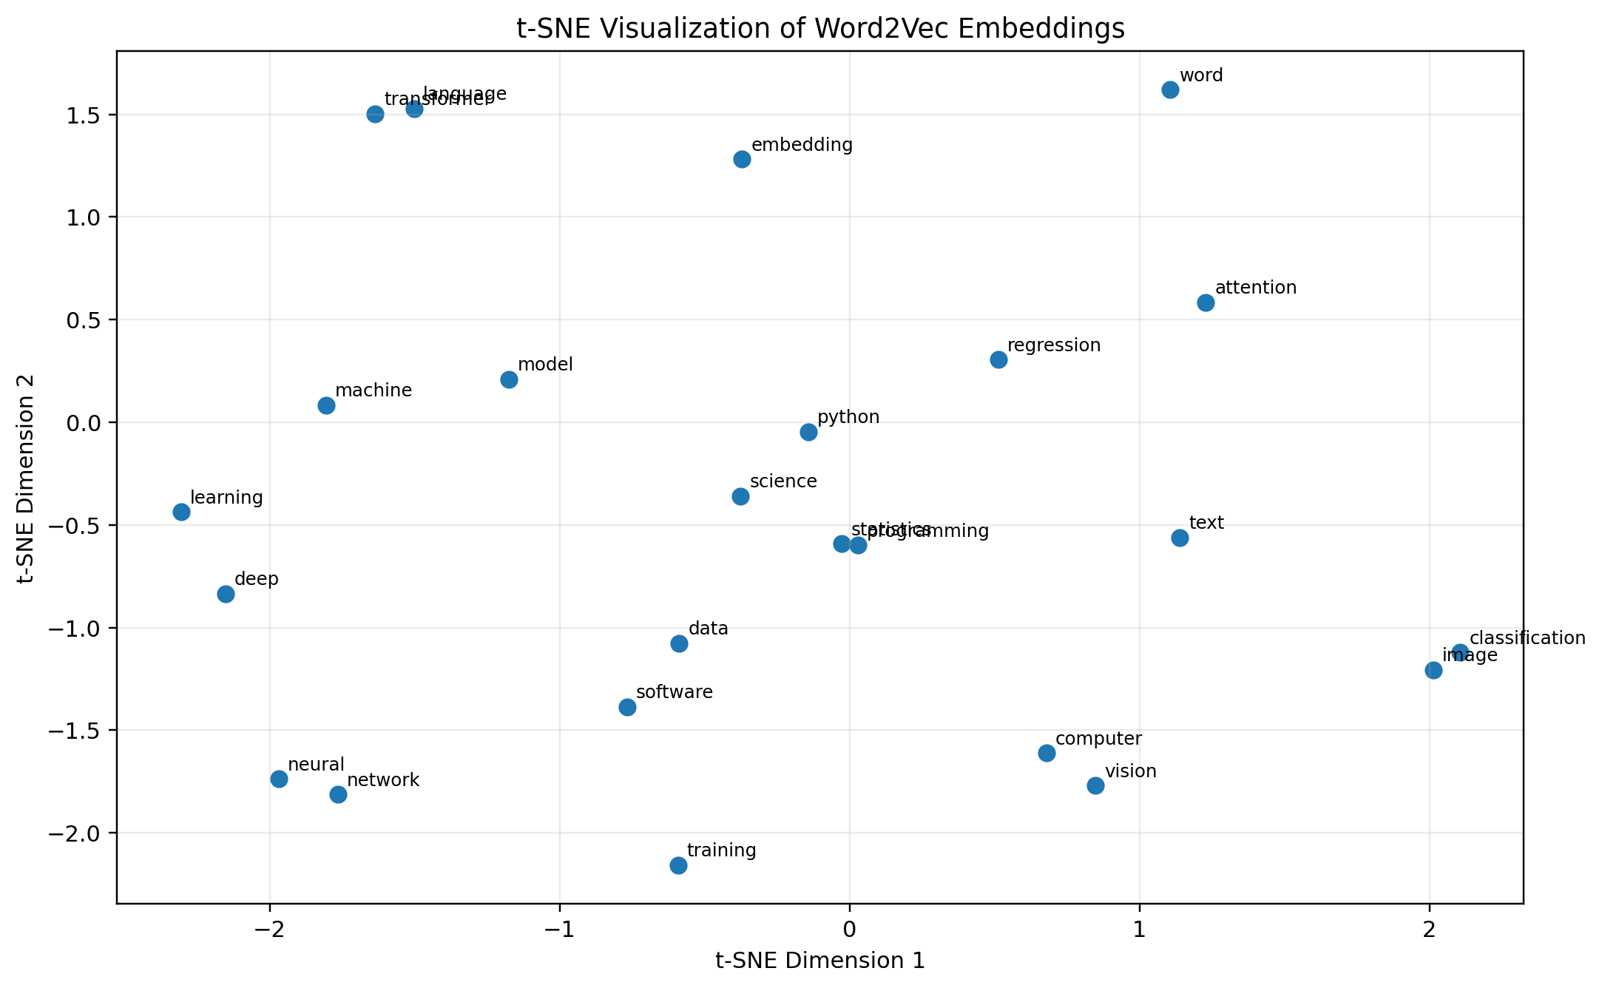
Figure 2. t-SNE projection of the same selected Word2Vec vectors. t-SNE emphasizes local neighbourhoods; distances between far-apart groups should not be interpreted as exact semantic distances.

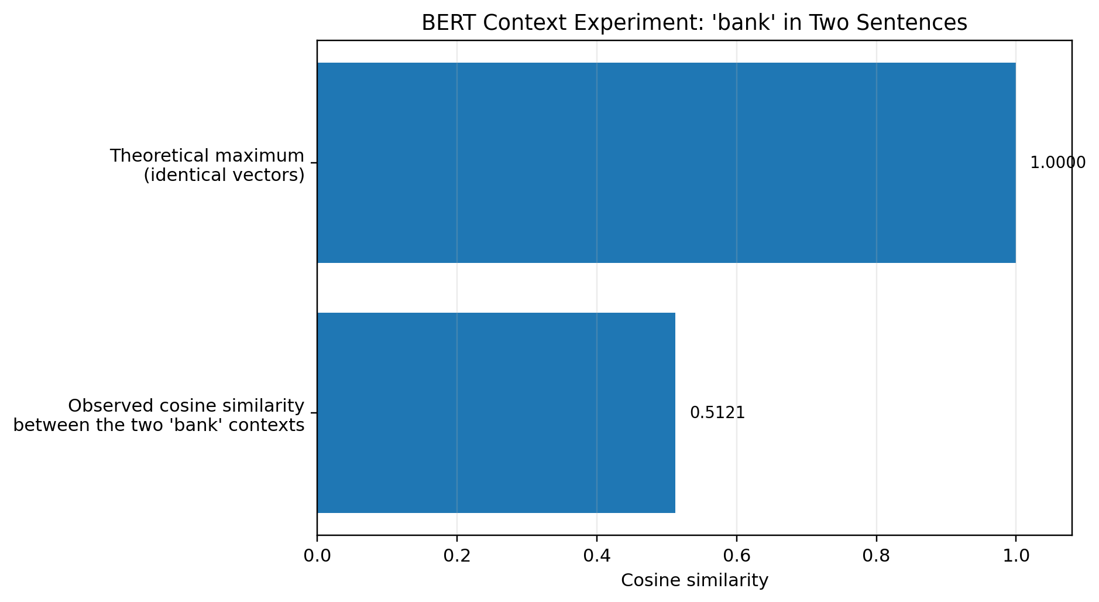
Figure 3. BERT context experiment. The observed cosine similarity between the two “bank” token vectors is 0.5121; 1.0 is shown only as the theoretical maximum for identical vectors.

7.1 How to open the vectors in TensorFlow Embedding Projector
- Run the notebook cells that create the embedding_projector folder.
- Locate vectors.tsv and metadata.tsv in the notebook environment and download both files.
- Open https://projector.tensorflow.org/ in a browser.
- Use the load/upload option to provide the vectors file and its matching metadata file.
- Choose PCA, t-SNE or UMAP in the projector and inspect nearby words. The metadata file contains word labels so points can be identified.
The notebook exports 26 word vectors and their word labels. This is a small demonstration set intended for interactive inspection, not a full-corpus embedding visualization.

8. Comparative Analysis
Criterion | Traditional (BoW / TF-IDF) | Static (Word2Vec / FastText) | Contextual (BERT)
Semantic representation | Term frequency and document importance; limited synonym knowledge. | Dense vectors learn neighbourhoods from local context. | Token meaning is influenced by the full input context.
OOV handling | New terms generally need vocabulary updates or become ignored/unknown. | Word2Vec does not represent unseen words; FastText can use subword n-grams. | WordPiece tokenization splits many unseen words into subword units.
Context awareness | No true contextual word meaning. | One fixed vector per word regardless of sentence. | Different occurrences of the same word can have different vectors.
Computational cost | Low; sparse matrices can be large. | Usually moderate; training is feasible on CPU for small data. | Higher; pretrained model inference uses more memory and compute.
Best use cases | Baselines, keyword matching, document classification. | Similarity features and compact representations. | Context-sensitive NLP, question answering and semantic tasks.

9. Limitations
- The dataset is a small, built-in corpus of 100 documents and 10 topics; results may change on larger or more varied text.
- The Keras classifier achieved only 25% test accuracy, so the learned embeddings are not demonstrated to be strong for classification.
- GloVe and SBERT appear in the comparison table as techniques for conceptual comparison, but this notebook does not run dedicated GloVe or SBERT experiments.
- The visualizations are two-dimensional projections of selected words. Projection methods distort some relationships, so plots should be interpreted together with cosine similarity and the original vectors.
- The notebook’s high Word2Vec cosine scores may reflect repeated phrases and the small vocabulary, not necessarily robust general-purpose semantics.

10. Conclusion
This assignment demonstrates how text representations progress from sparse statistical features to dense static embeddings and contextual Transformer vectors. One-Hot, BoW and TF-IDF are simple and efficient but do not directly capture semantic similarity. LSA compresses a term matrix into latent dimensions. Word2Vec learns useful local-context representations, while FastText extends this approach with character subwords and can create a vector for an unseen word. The Keras Embedding layer learns task-oriented vectors, although the recorded 25% test accuracy shows that this small dataset and model setup are insufficient for reliable classification. BERT produces context-dependent vectors: the two uses of “bank” had cosine similarity 0.5121. PCA, t-SNE and TensorFlow Embedding Projector provide ways to inspect vector relationships, but projections must be interpreted carefully.

References
- Mikolov, T. et al. (2013). Efficient Estimation of Word Representations in Vector Space.
- Pennington, J., Socher, R., and Manning, C. (2014). GloVe: Global Vectors for Word Representation.
- Bojanowski, P. et al. (2017). Enriching Word Vectors with Subword Information.
- Devlin, J. et al. (2019). BERT: Pre-training of Deep Bidirectional Transformers for Language Understanding.
- Gensim documentation: Word2Vec and FastText — https://radimrehurek.com/gensim/
- Hugging Face Transformers documentation — https://huggingface.co/docs/transformers
- TensorFlow Text tutorials — https://www.tensorflow.org/text
- TensorFlow Embedding Projector — https://projector.tensorflow.org/

